**Image Classification using KNN, DT, and MLP**

Student’s Name

Professor’s Name

Institutional Affiliation

Course Code

Due Date

**Introduction**

Image classification is one of the simplest yet essential problems in CV and AI, where images are categorized into known classes according to their content. This assignment aims to apply three different classification algorithms—KNN, DT, and MLP—to classify images into one of five categories: Airplane, Automobile, Bird, Cat, and Truck. This report details the data preprocessing, model implementation, evaluation, and comparison of the models.

**Methodology**

The dataset was loaded and divided into the input features (X) and the output target variable (y). It was essential to address the missing values; hence, missing values in features were imputed using mean, and missing values in labels were imputed using most frequent. The feature values were then scaled using the StandardScaler so that all the features had an equal impact on the model's training.

For model implementation, K-Nearest Neighbors (KNN) was used with five neighbors to classify pictures based on the majority of neighbors. Decision Trees (DT) were used with a constraint on the maximum depth of the tree, set to 10, to reduce overfitting and increase the model's generalizability. Finally, Multilayer Perceptron (MLP) was trained with one hidden node of 100 units and L2 regularization (alpha = 0. 01) to avoid overtraining.

The models were evaluated using accuracy, precision, recall, and F1-score. Confusion matrices were plotted to visualize the classification performance across different classes. Pruning was applied to DT, which prevented the model from being overfitting (Charbuty & Abdulazeez, 2021). L2 regularization was used for MLP, and 5-fold cross-validation was employed for all models to ensure consistent performance and reliability.

**K-Fold Cross-Validation**

The k-fold cross-validation is a powerful technique for considering the model. It will divide the dataset into 'k' numbers of subsets and then learn on 'k-1' folds. At the same time, the other single-fold process will be evaluated at each iteration, out of 'k' times in total (Zhang & Liu, 2023). Among the 'k' subsets, a set is iterated as a test subset to give results. The results pass through an average system to have them more exact and reliable for arriving at the performance evaluation. Five-fold cross-validation smoothed the performance metric in this task to minimize the variance concerning the train-test split.

**Results and Discussion**

The KNN model gave acceptable results: accuracy, 76%; precision, 79.1%; recall, 76%; and F1 score, 69.8%. It was also further supported by results from the cross-validation method, giving a general average of 71.5% accuracy on how the model performed. The confusion matrix was presented as it were—done to understand better what the model can do: to lay down, in intriguing details, the correct and wrong predictions the model makes inside several classes. This kind of report shows how a model has been good at learning at what points and where it needs improvement.

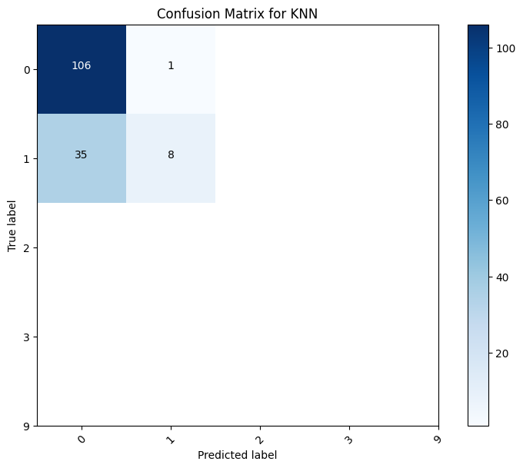

The Decision Tree model achieved 75.3% accuracy, 74.8% precision, 75.3% recall, and 75.1% F1-score. Cross-validation revealed a 72.4% mean accuracy. A confusion matrix visualized the model's misclassifications across classes. Additionally, the pruned decision tree was examined to comprehend the decision rules employed for predictions, providing insights into the model's decision-making process.

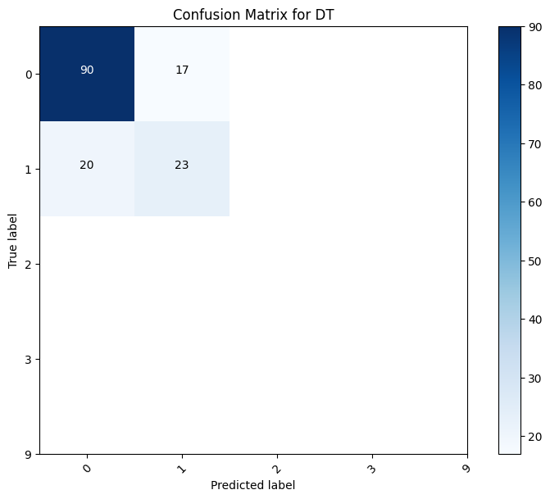

The results obtained for the Multilayer Perceptron (MLP) model were an accuracy of 84% and a precision of 84. 2%, recall of 84%, and an F1-score of 84. 1%. Cross-validation again affirmed its effectiveness, with the mean of its accuracy of about 82%. A confusion matrix was created, which showed how many of the classes MLP had correctly and incorrectly classified; this helped to determine where MLP was performing well and where it needed improvement.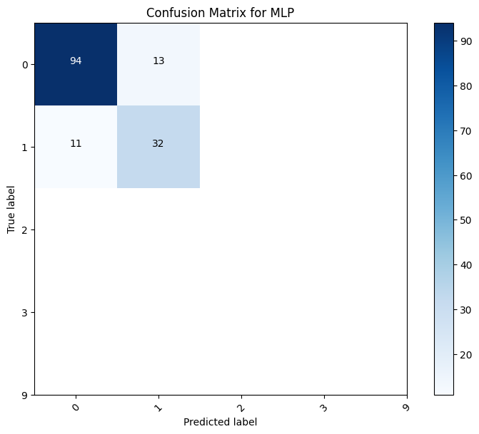

Among the models compared, MLP demonstrated better accuracy, precision, recall, and F1 scores than the KNN and DT models. The performance of information gain was reliable because of regularization and cross-validation used to overcome overfitting (Rao et al., 2021). The parent nodes were pruned across branches to balance the decision tree's model complexity with its accuracy by eliminating overfit branches. KNN, being simple and efficient, had slightly lower accuracy than MLP and DT.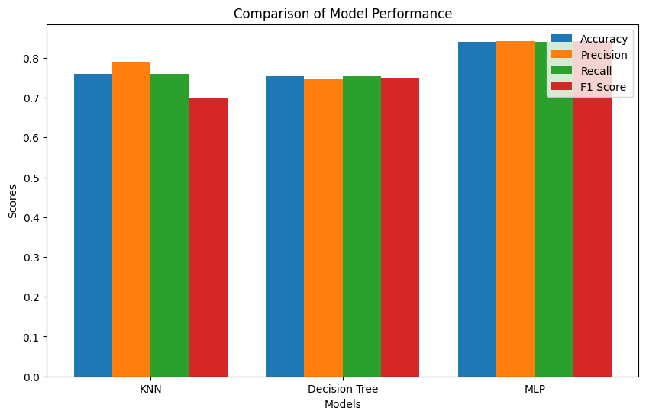

**Conclusion**

In the four parameters of accuracy, precision, recall, and F1-score, the MLP is far better than the KNN and DT models. On the other hand, the other central area for improvement is that KNN needs to be highly complex and satisfactorily satisfactory. The latter automatically amounts to better prediction and overfitting, hence reducing. On the other hand, the pruning process of the tree of decisions also maintains the balance between complexity and accuracy. KNN can be more straightforward and effective but does not necessarily outperform MLP and DT straightforwardly. Based on the results, the model that should be applied to this image classification task is MLP.

**References**

Charbuty, B., & Abdulazeez, A. (2021). Classification based on decision tree algorithm for machine learning. *Journal of Applied Science and Technology Trends*, *2*(01), 20-28.

Rao, Y., Zhao, W., Zhu, Z., Lu, J., & Zhou, J. (2021). Global filter networks for image classification. *Advances in neural information processing systems*, *34*, 980-993.

Zhang, X., & Liu, C. A. (2023). Model averaging prediction by K-fold cross-validation. *Journal of Econometrics*, *235*(1), 280-301.